Act#1

r=1e3;

c=1e-6;

l=1e-3;

num=[1];

denum=[l\*c (l/r) 1];

sys=tf(num,denum)

step(sys)



Act#2

m=1580;

b=26;

num=[1];

denum=[m b];

sys=tf(num,denum)

step(sys)



ACT#3

r=1e3;

c=1e-6;

num=[0 1];

denum=[r\*c 1];

sys=tf(num,denum)

step(sys)



Act#1

clear all

num=[25];

den=[1 10 25];

system=tf(num,den);

step(system)

stepinfo(system)

struct with fields:

RiseTime: 0.6717

SettlingTime: 1.1668

SettlingMin: 0.9008

SettlingMax: 0.9999

Overshoot: 0

Undershoot: 0

Peak: 0.9999

PeakTime: 2.390



Act#2

num=[500];

den=[1 14.14 100];

system=tf(num,den);

step(system)

stepinfo(system)

struct with fields:

RiseTime: 0.2149

SettlingTime: 0.5963

SettlingMin: 4.5179

SettlingMax: 5.2163

Overshoot: 4.3251

Undershoot: 0

Peak: 5.2163

PeakTime: 0.4429



Act#3

num=[500];

den=[1 10 500];

system=tf(num,den);

step(system)

stepinfo(system)

struct with fields:

RiseTime: 0.0553

SettlingTime: 0.7561

SettlingMin: 0.7639

SettlingMax: 1.4852

Overshoot: 48.5150

Undershoot: 0

Peak: 1.4852

PeakTime: 0.1474



Act#4

num=[0 0 25];

den=[1 0 25];

system=tf(num,den)

step(system)

stepinfo(system)

system =

25  
--------

s^2 + 25

Continuous-time transfer function.

ans =

struct with fields:

RiseTime: NaN

SettlingTime: NaN

SettlingMin: NaN

SettlingMax: NaN

Overshoot: NaN

Undershoot: NaN

Peak: Inf

PeakTime: Inf



Act#5

num=[0 100 0];

den=[1 0 -25];

system=tf(num,den)

step(system)

stepinfo(system)

100 s

--------

s^2 - 25

Continuous-time transfer function.

ans =

struct with fields:

RiseTime: NaN

SettlingTime: NaN

SettlingMin: NaN

SettlingMax: NaN

Overshoot: NaN

Undershoot: NaN

Peak: Inf

PeakTime: Inf



Act#6

num=[0 0 30 180];

den=[1 4 13 0];

system=tf(num,den);

impulse(system);

stepinfo(system);



Act#1

close all

clear al

r=220;

c=1e-6;

num=[0 1];

den=[r\*c 1];

sys=tf(num,den)

fc=(1/(2\*pi\*r\*c))\*(2\*pi)

[mag,phase] = bode(sys,fc)

[mag,phase] = bode(sys,[1e6 400e3 100e3 30e3 10e3])

subplot(2,1,1)

bode(sys),grid on

subplot(2,1,2)

bode(sys,{1e2 1e4}),grid on



Act#2

close all

clear al

r=220;

c=1e6;

num=[0.004867 1.947 194.7];

den=[1 333.7 0.32];

sys=tf(num,den)

fc=(1/(2\*pi\*r\*c))\*(2\*pi)

[mag,phase] = bode(sys,fc)

[mag,phase] = bode(sys,[0.024492 0.463464 6.60656 94.252124 7023.623])

subplot(2,1,1)

bode(sys),grid on

subplot(2,1,2)

bode(sys,{1e2 1e3}),grid on`



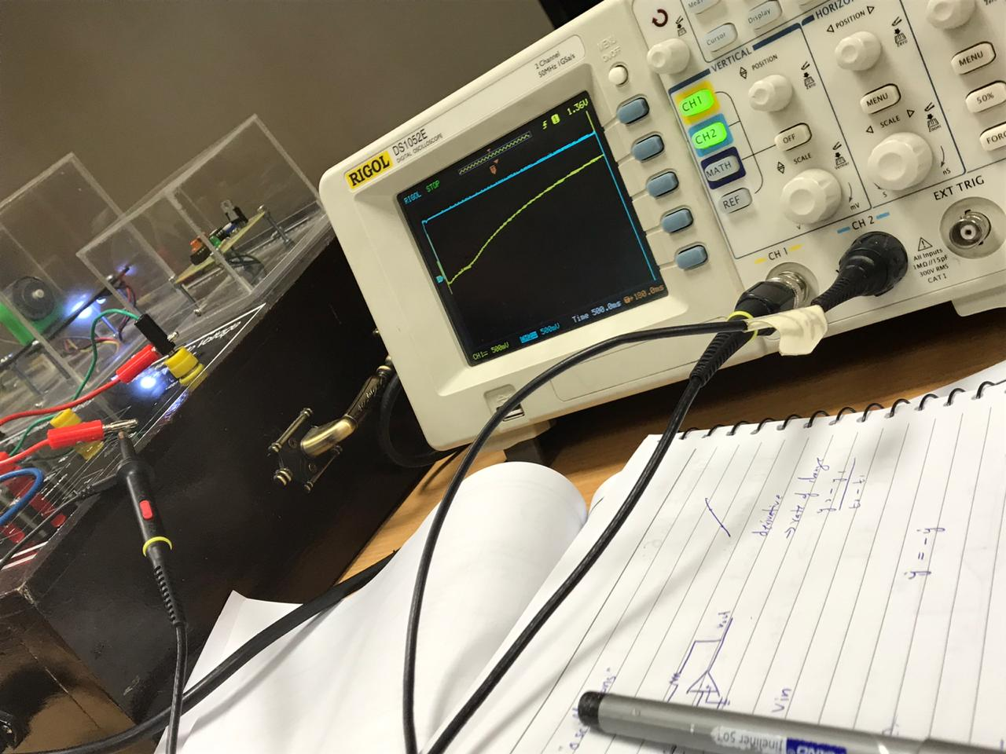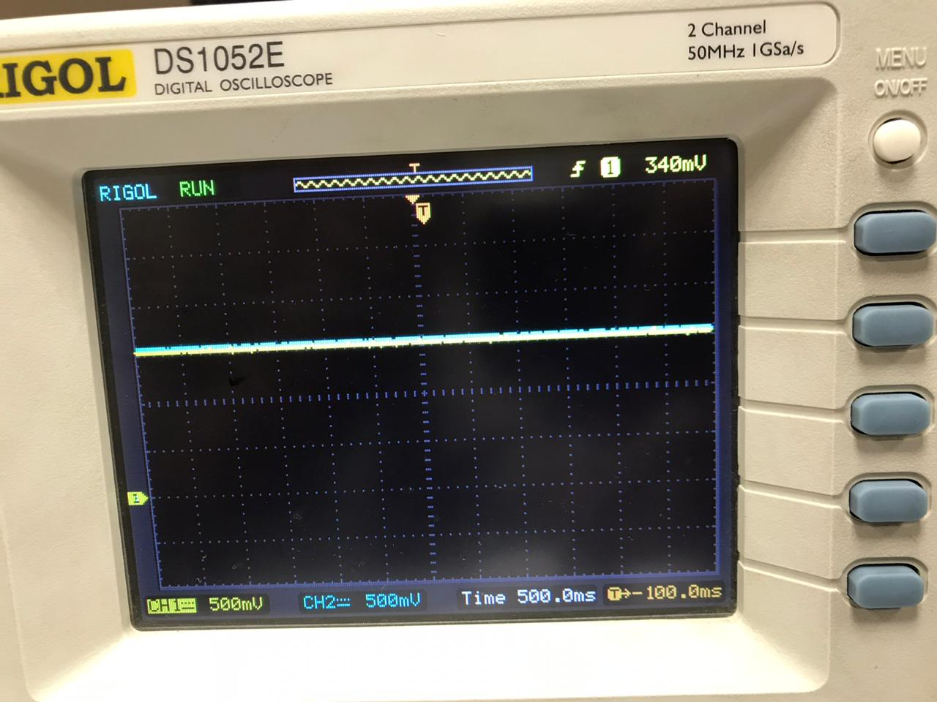

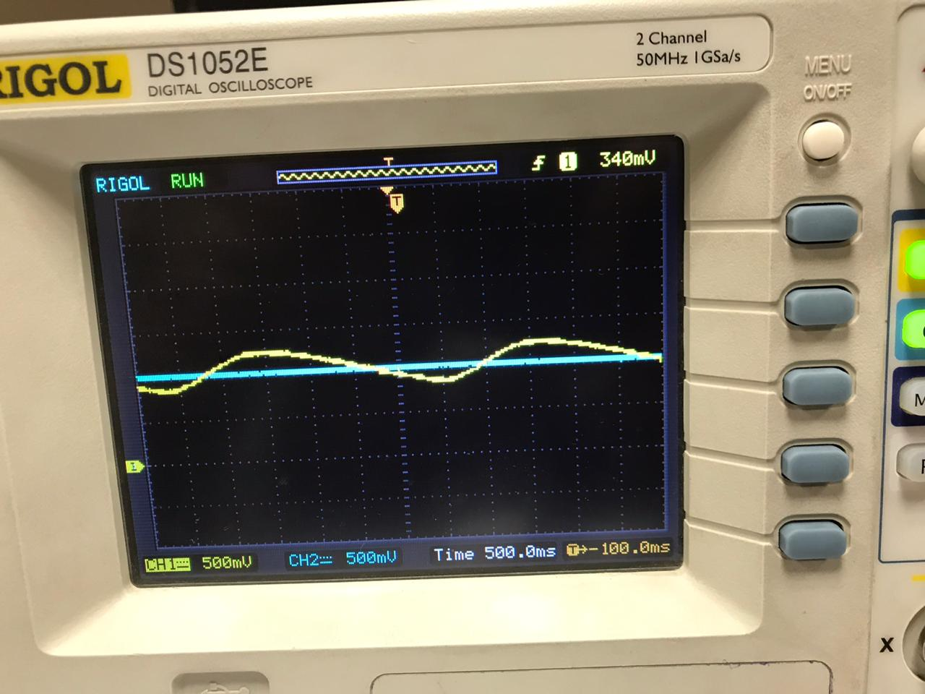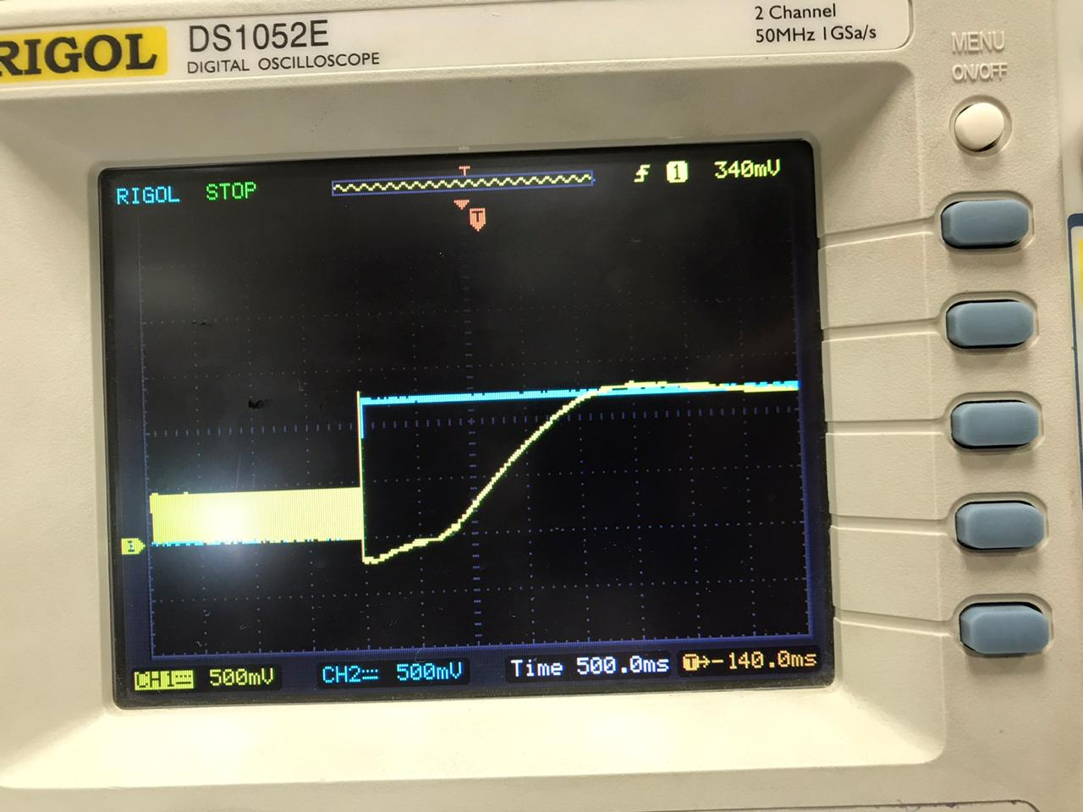

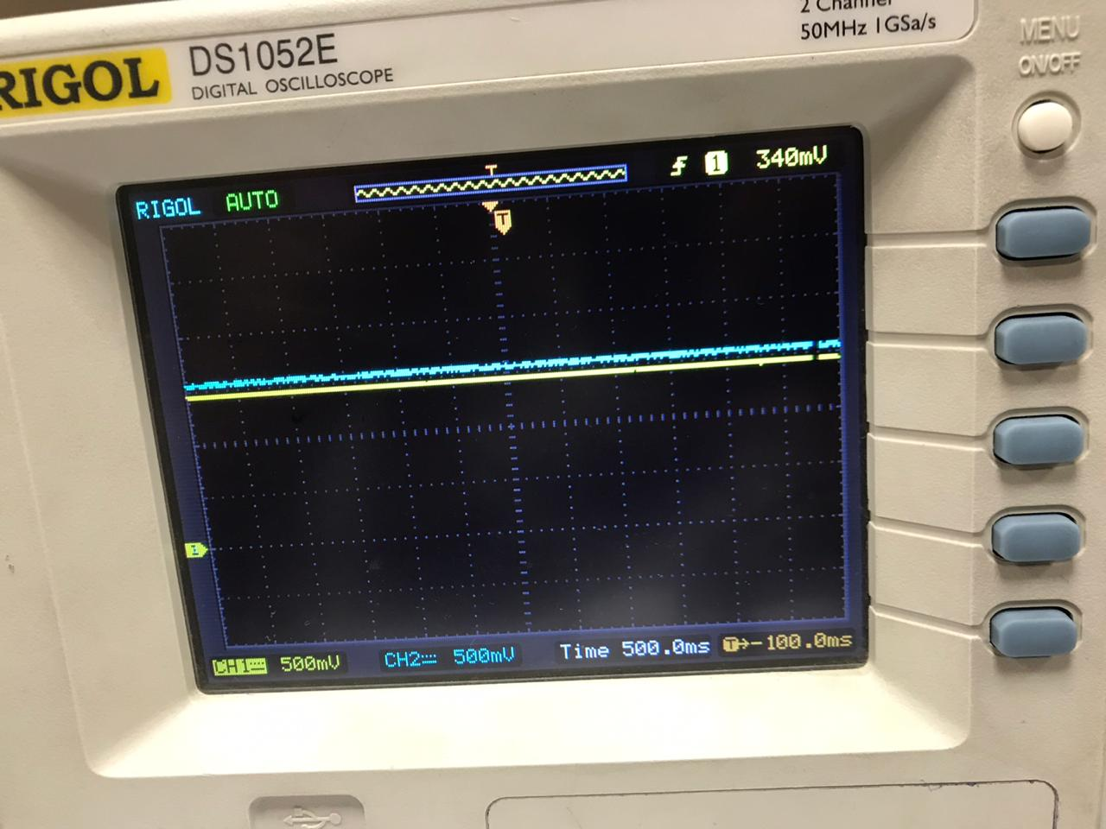

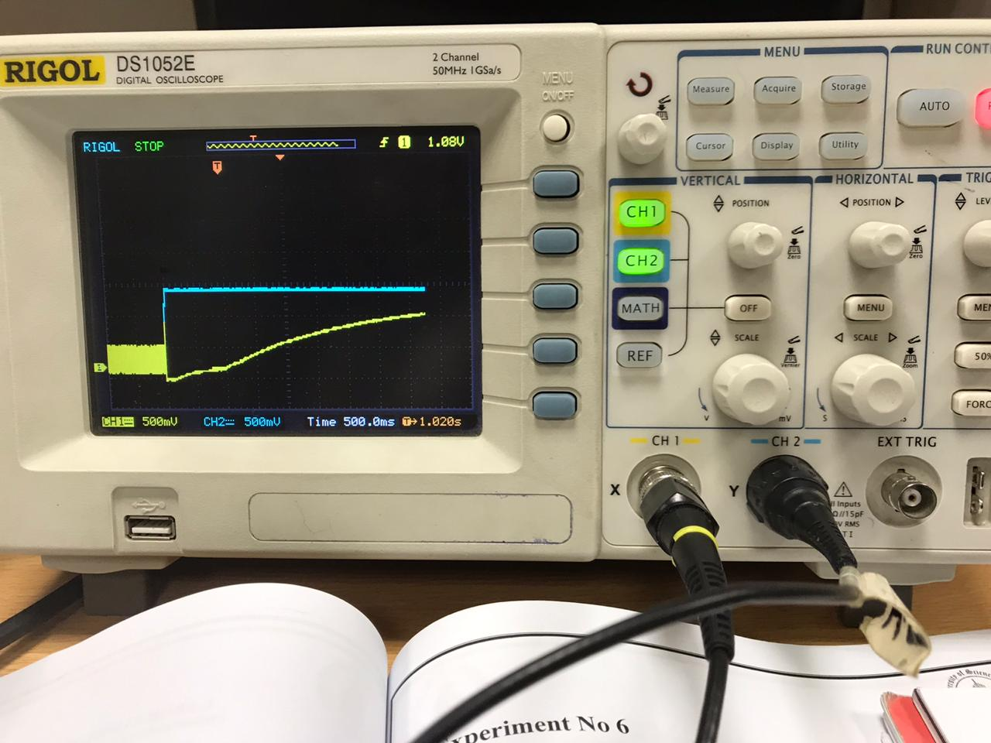

close all

clear all

m=2;

b=-1;

k=3;

num=[1];

denum=[m b k];

sys=tf(num,denum)

roots(denum)

Continuous-time transfer function.

ans =

-0.2500 + 1.1990i

-0.2500 - 1.1990i

>> Untitled

Continuous-time transfer function.

ans =

0.2500 + 1.1990i

0.2500 - 1.1990i

After kp and ks

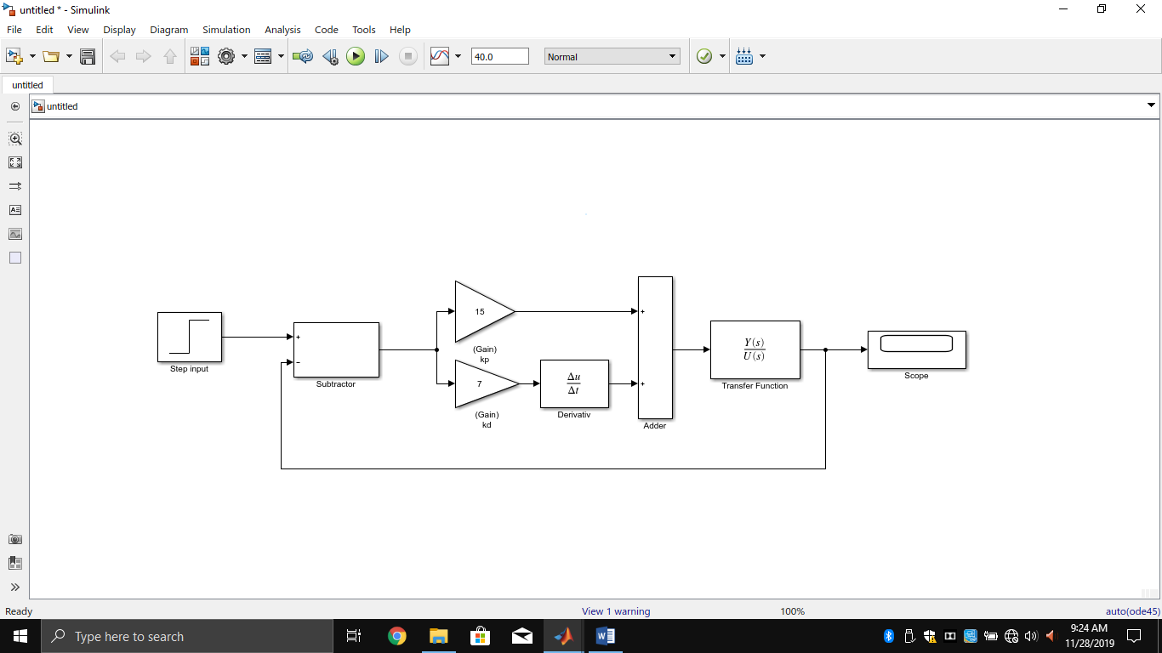

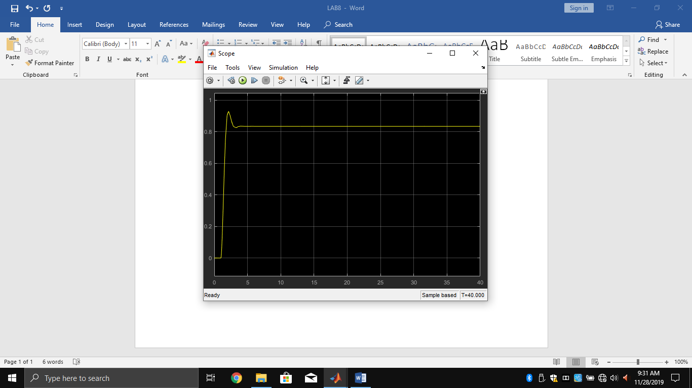

Using PID

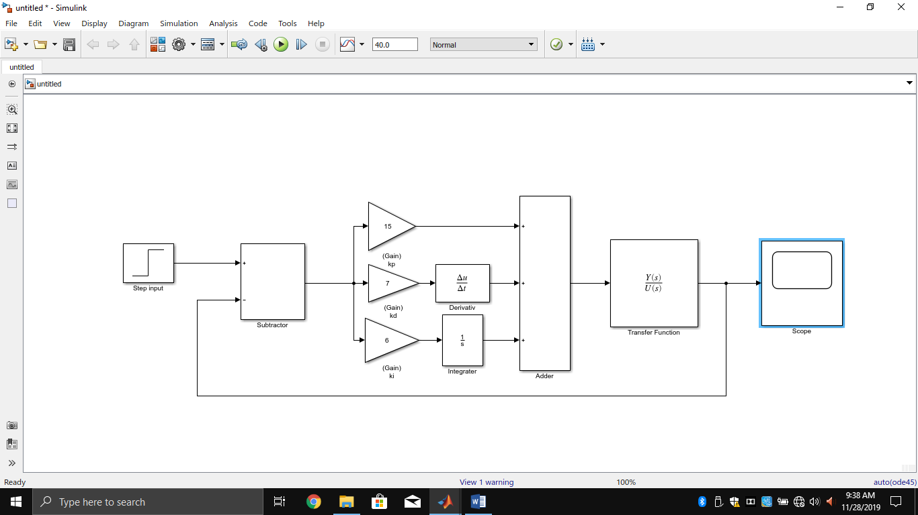

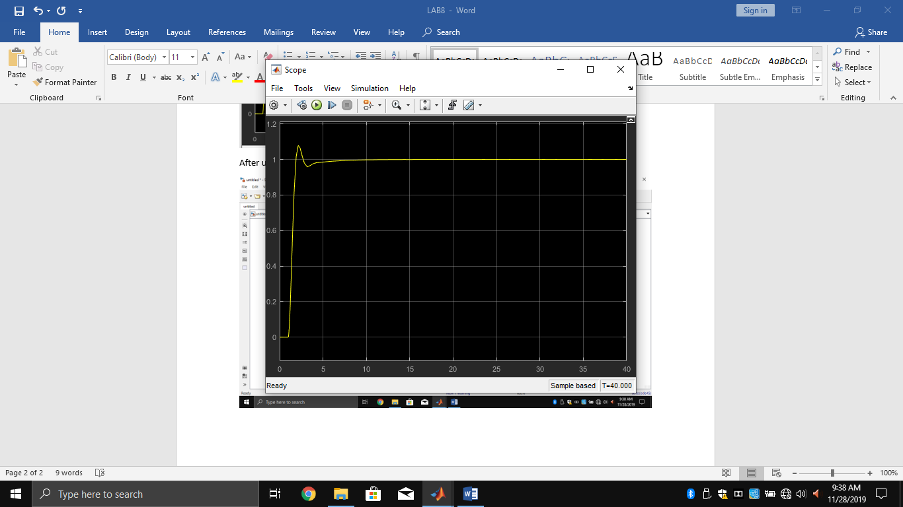

After Adding Disturbance of 5 newton

